**STEP 1: CHOOSE A RACE!**

**HOW TO CREATE A DUNGEONS & DRAGONS CHARACTER**

Your race will determine what your character looks like. Choose one of the following races and input it into your Design Sheet:

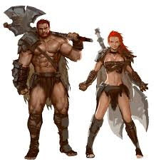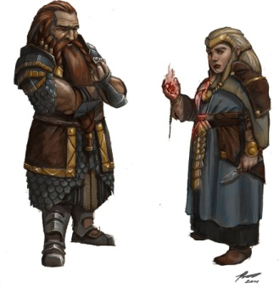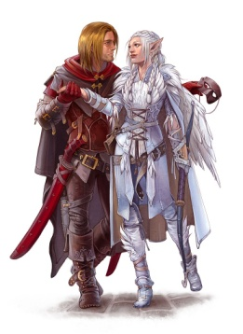 **Dwarf Elf Halfling Human**

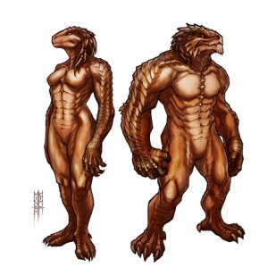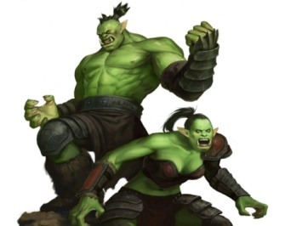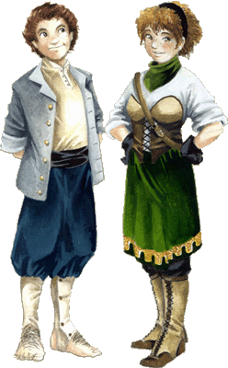

**Orc Dragonborn**

**STEP 2: CHOOSE A CLASS!**

Your class determines your characters abilities, equipment and role within your team. The next page contains descriptions of each class and the starting equipment your character will have if you choose that class. Copy your class’ equipment and other items into their respective sections on the Design Sheet.

**ATTENTION:** If you chose the Wizard or Cleric class, please go to the **Wizard/Cleric** section on page 4 to learn about the different spells available to you.

Very tall and strong creatures. They have scaled skin and heads like a dragon.

Very large and muscular. They have green skin and large fanged teeth.

Shorter than Dwarves, but very nimble and cheerful. Very hairy.

Average height and very diverse race.

Tall, elegant creatures with sharp ears and pale skin.

Small but sturdy, usually have very long hair and facial hair. Short Tempered.

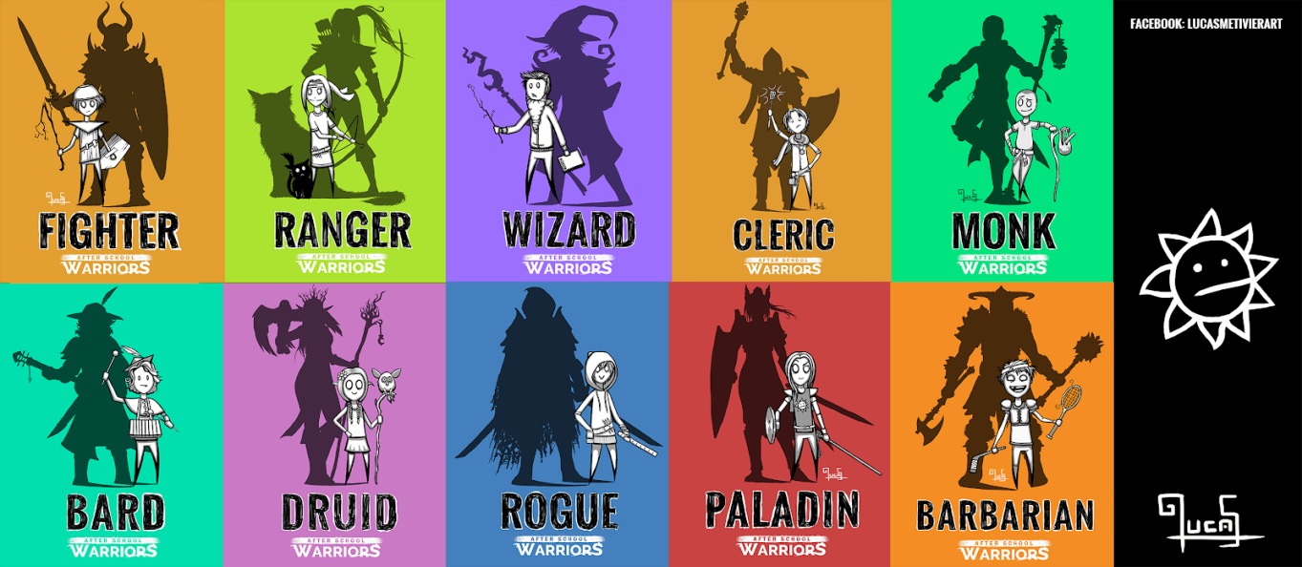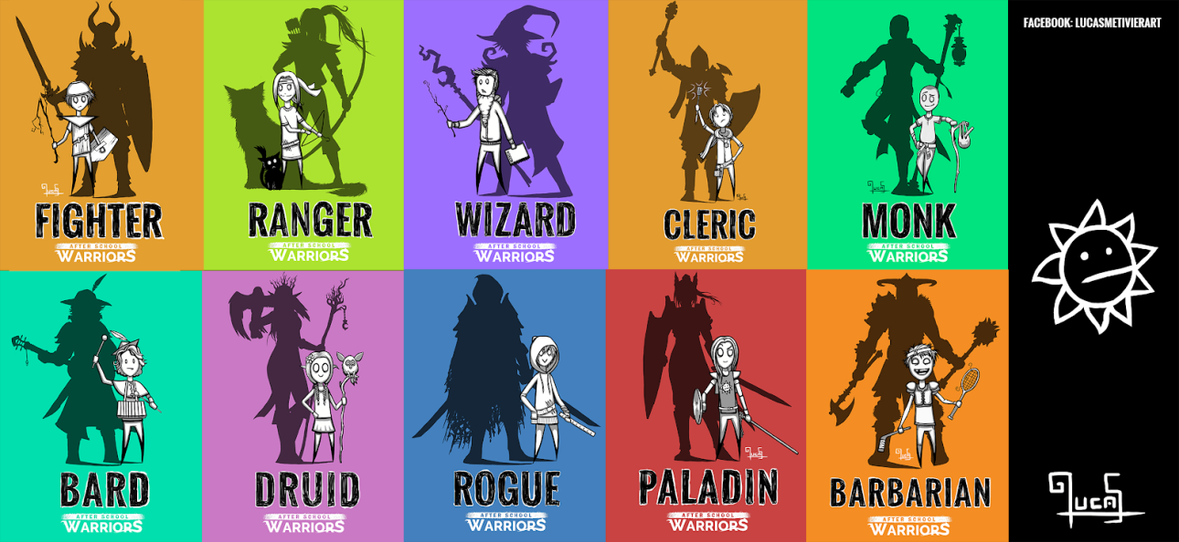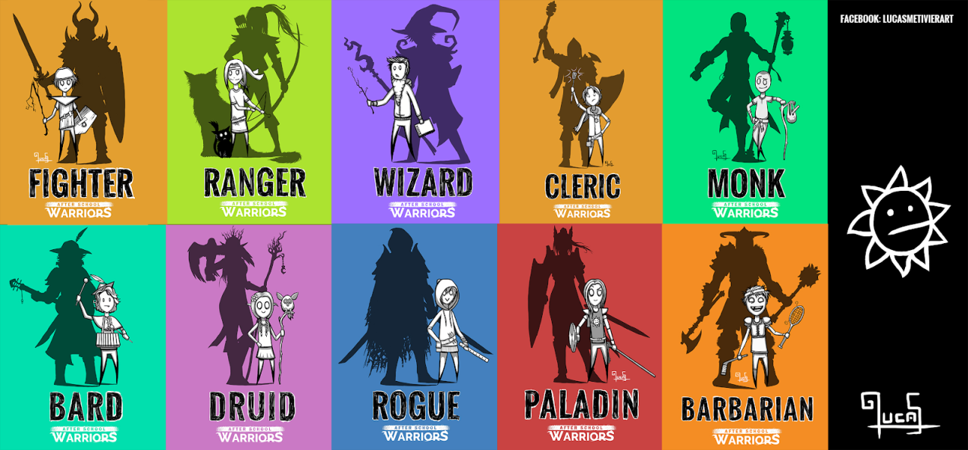

**C  
L  
A  
S  
S  
  
S  
E  
L  
E  
C  
T  
I  
O  
N**

**Description:** A master of martial combat, skilled with a variety of weapons and armor. Fighters can turn the tide of battle at any moment.  
**Special Attribute:** Strength

**Equipment:** Sword, Short Bow, 20 Arrows, Shield, Medium Armour

**Description:** Rogues rely on skill, stealth, and trickery to get the upper hand in any situation. They have a knack for finding the solution to just about any problem, bringing resourcefulness and versatility to their adventuring parties.  
**Special Attribute:** Dexterity

**Equipment:** Rapier, Throwing Knives, Light Armour

**Description:** Warriors of the wilderness, Rangers specialize in using their knowledge of the outdoors to track foes and provide advantages in combat. They are in tune with nature and can befriend wild animals.  
**Special Attribute:** Dexterity  
**Equipment:** Longbow, 20 Arrows, Dagger, Light Armour  
**Choose One Companion:** Eagle, Panther, Wolf, Giant Frog, Baboon

**Description:** Wandering as a musician across the land, telling stories, working magic with his music, and living on the gratitude of his audience—such is the life of a bard. When chance or opportunity draws them into a conflict, bards serve as diplomats, negotiators, messengers, scouts, and spies.  
**Special Attribute:** Charisma  
**Equipment:** Sickle, Instrument, Light Armour  
**Choose One Instrument:** Lute, Harp, Flute, Horn, Drum, Bagpipes

**Description:** Drawing on the subtle weave of magic that permeates the cosmos, wizards cast spells of explosive fire, arcing lightning, subtle deception, and brute-force mind control.  
**Special Attribute:** Intelligence  
**Equipment:** Staff, Spellbook, Dagger, Light Armour  
**Choose Two Spells:** Fire Bolt, Charm Person, Gust, Thunderclap, Earth Tremor, Ice Bolt

**Description:** Clerics are the embodiment of their God’s blessings. They are primarily healers using their divine magic, but are also capable warriors when involved in a fight.  
**Special Attribute:** Intelligence  
**Equipment:** Mace, Shield, Medium Armour  
**Spells:** Healing Touch, Bless

**Description:** A fierce warrior of primitive background who acts as a meat shield for the party. Barbarians excel in combat, possessing the martial prowess and fortitude to take on foes seemingly far superior to themselves.  
**Special Attribute:** Constitution  
**Equipment:** Great axe, Two Handaxes, Heavy Armour

**STEP 3: ASSIGN YOUR CHARACTER STATS!**

This is the bread and butter of your characters personality. Character stats will be assigned using what is called a **Standard Array**. These numbers are what you will be assigning to your attributes:

15 14 13 12 8

Depending on what class you chose, you must put your highest number in the array (which is 15) into the **Special Attribute** designated within the class selection page on your Character Design Sheet.

For example, a Ranger would have a Dexterity value of 15.

The higher the number, the better your character will be in that area of their skills. Below is a description of what each attribute means:

**Stat Description**

|  |  |
| --- | --- |
| Strength (STR) | Measures your physical power (How strong you are) |
| Dexterity (DEX) | Measures your Agility (How quick and nimble you are) |
| Constitution (CON) | Measures your Endurance and Health (How tough and durable you are) |
| Intelligence (INT) | Measures your Reasoning and Memory (How smart you are) |
| Charisma (CHR) | Measures your Personality and Talking ability (How social you are) |

Once you have inputted your highest number from the Standard Array into your characters Special Attribute, it’s time to assign the rest of your numbers to the other attributes.

**STEP 4: NAME YOUR CHARACTER!**

Every great character needs an even greater name. You can decide to give your character an Earth name, name it after yourself or even come up with a fun fantasy name! The possibilities are endless.

**STEP 5: DRAW YOUR CHARACTER!**

Now that you have created your character, it’s time to bring them to life! Draw what you imagine your character looks like based on everything you have selected so far.

A tip for starting to draw your character is to draw what their face and hairstyle look like. Do they have blonde hair? Facial hair? Any tattoos or markings? Are they happy or angry?

Then focus on the type of build their body might have, are they muscular? Are they tall or short? Do they have lots of armour on or mostly clothes?

Try to incorporate their personality and equipment into the drawing. For example a Rogue character should look sneaky or sly and might be holding a throwing knife.

Once you have finished drawing your character, you can add the picture to your Character Design Sheet in the Portrait frame.

**Wizard/Cleric Section – ONLY FOR THOSE THAT CHOSE THESE CLASSES**

So you want to play around with magic eh? If choosing the Wizard or Cleric class, here are the descriptions for the available spells. Wizards get to choose **two** spells from the Wizard Spells list, but Clerics will only be able to use spells from the Cleric Spell list.

**Wizard Spells:**Charm Person:You may attempt to charm a humanoid you see within range into being friendly.  
  
Earth Tremor:You cause a tremor in the ground within range. Each creature other than you takes damage.  
  
Fire Bolt: You hurl a bolt of fire at a creature or object in range.  
  
Gust: You may push a creature or object 5-10 feet away from you.  
  
Ice Bolt: You hurl a bolt of magical frost at a creature or object in range.  
  
Thunderclap: You create a burst of thunderous sound that can be heard up to 100 feet away. Creatures within range can take thunder damage.

**Cleric Spells:**  
Bless: You may bless up to three creatures within range, those creatures may roll an extra time for actions.  
  
Healing Touch: A willing creature that you touch regains health.

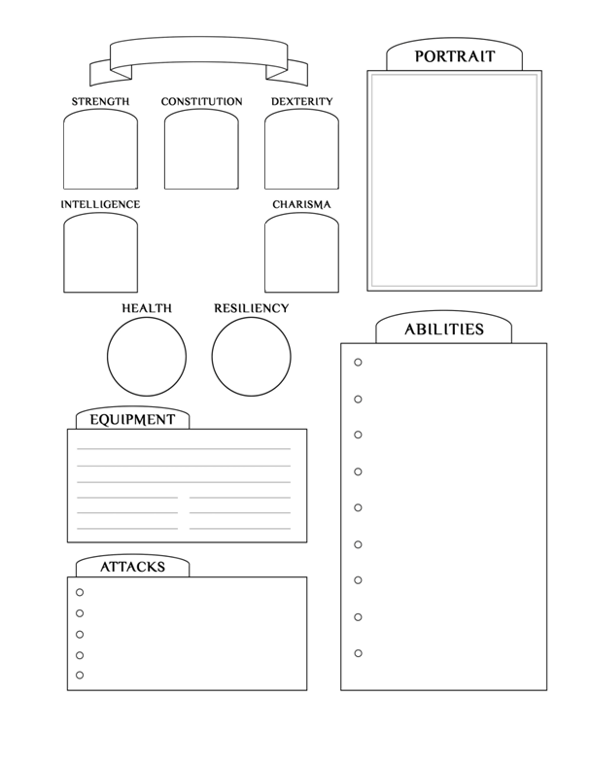

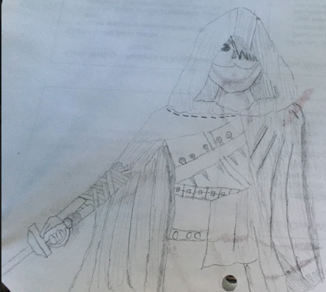

Roronoa

15

12

13

14

8

**Rapier**

**Throwing Knives**

**Light Armour**

**Spells**

**Name:**

**Character Design Sheet**

**Race: Human**

**Class: Rouge**

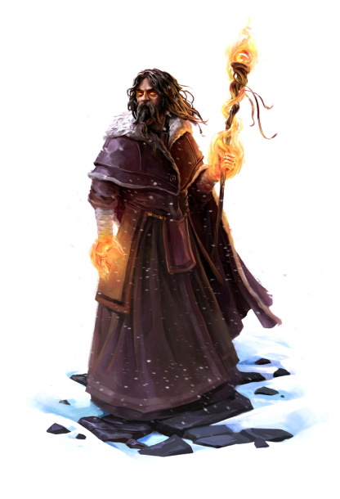

Leave blank for now!

Staff  
Spellbook  
Dagger  
Light Armour

**Race:** Human

**Class:** Wizard

15

8

13

**Name:**

**WIZARD EXAMPLE**

**Aar Spitter of Fire**

12

14

Fire Bolt

Charm Person

**Spells**

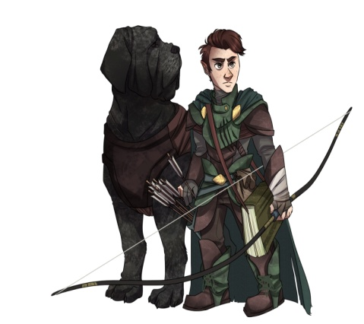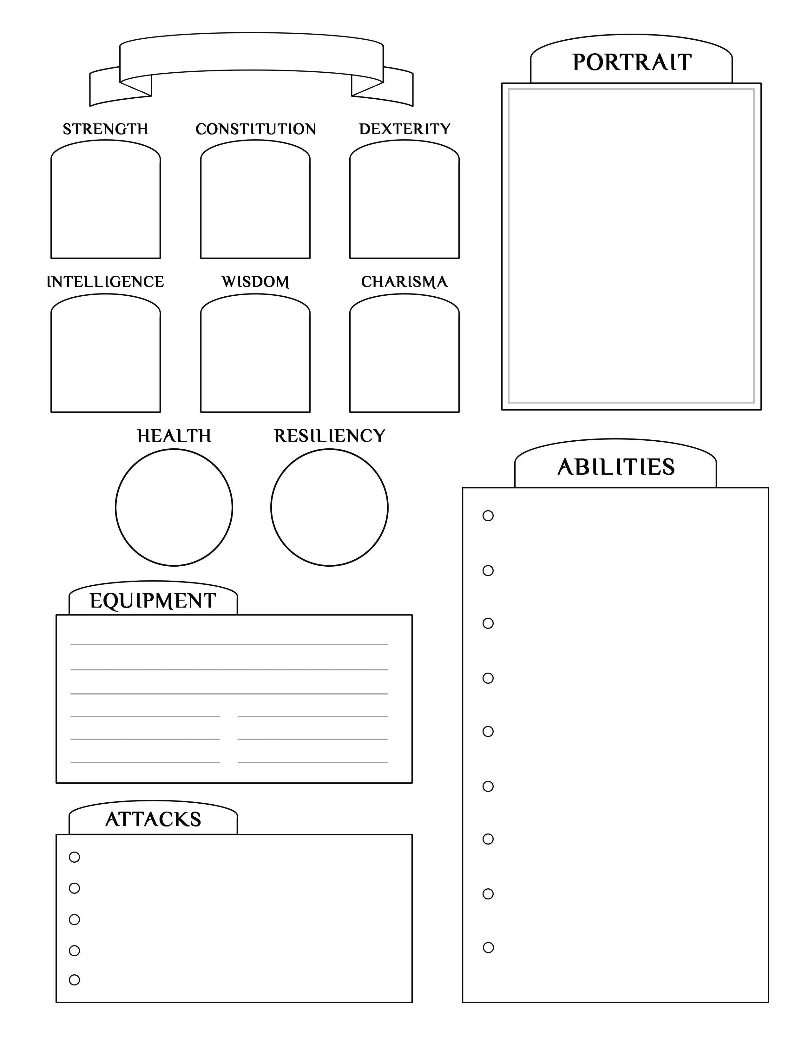

**RANGER EXAMPLE**

**Name:**

Leave blank for now!

**Spells**

Tarus Beestinger

**Race:** Halfling

**Class:** Ranger

8

13

12

15

14

Longbow  
20 Arrows  
Dagger

Light Armour  
Companion: Atticus the Wolf